Pirean/IDAMs to DSI migration

A design history of content journeys

**Initial comms email** **3**

Initial draft (words only) 3

Second draft (visualised in prototype) 3

**Initial comms guidance page** **5**

Initial draft (words only) 5

Second draft (words only) 6

Third draft 8

Edits after 1 round of user research 9

**Initial comms - landing page content** **11**

First draft 11

**Account set up - email invitation for END USERS** **12**

First draft 12

Second draft 12

**Account set up - email invitation for APPROVERS** **14**

First draft 14

Second draft 14

**Invite journey confirmation page** **16**

**Account set up - new service added email FOR END USER** **18**

First draft 18

Second draft 18

**Account set up - new service added email FOR APPROVER** **20**

Second draft 20

**Content in DSI - My services page** **22**

Option A first draft 22

Option A second draft 22

Option B first draft 23

Option B second draft 23

**Cut off warning email** **25**

First draft 25

Second draft 25

**Post-migration confirmation email** **27**

First draft 27

Second draft 27

**Post-migration ‘You still need to set up an account’ email** **28**

First draft 28

Second draft 28

**Post-migration service landing page and DSI sign in page** **30**

First draft 30

Second draft 30

## 

## 

## 

## **Initial comms email**

#### Initial draft (words only)

**Email subject line**: Your access is changing: [service name]

**Email body content:**

Dear [name]

The way you access [service name] is changing. You do not need to do anything at this point.

From [date], you will need to have a DfE Sign-in account to access this service.

You can use your existing DfE Sign-in account if you already have one.

If you do not have a DfE Sign-in account, we will email you [how soon?] to set one up.

[Get more information about the move to DfE Sign-in](https://dfe-secureaccess.atlassian.net/wiki/spaces/NSA/pages/3241345025/Initial+comms+-+first+email#)

Kind regards,

The Department of Education Sign-in team

This is an automatically generated email; do not reply

Received this email in error? No action is necessary

#### 

#### Second draft (visualised in prototype)

This was initially drafted in a [Google Doc](https://docs.google.com/document/d/1d6wQmegbgCC47qK03jFZx7Xf73oQTAilGw8GmmXDc6g/edit?usp=sharing), and then transferred to the prototype for user testing. Some small changes were made to the copy as it was added to the prototype, such as:

* ‘You do not need to do anything at this point’ was moved to later in the email. This was based on the hypothesis that putting it at the start might discourage people from continuing to read the rest of the email; better to assure users of that fact later
* We are unable to confirm with certainty the timeline for emailing users to set up their account, and mentioning this in the initial comms email removes any flexibility. So we redrafted this to confirm we would email ‘soon’, as this is vaguer but informative
* We removed the line ‘You can use your existing DfE Sign-in account if you already have one’ as this felt confusing; users might think they could start to use their existing DSI account right away.

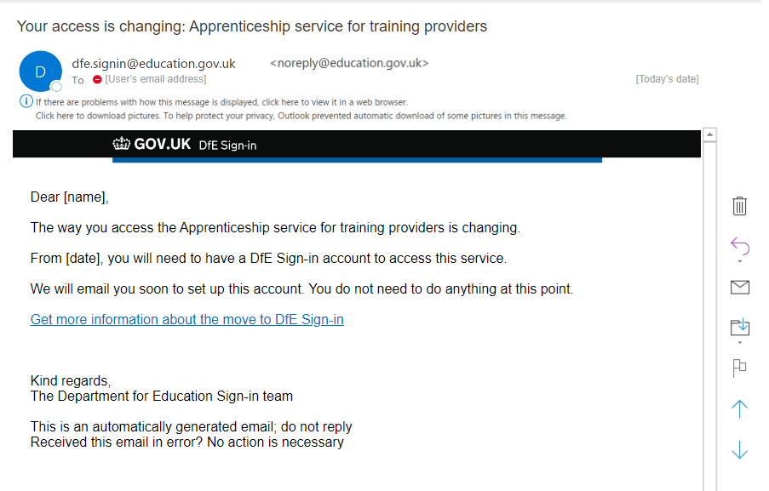

## 

## **Initial comms guidance page**

#### Initial draft (words only)

Get more information about the move to DfE Sign-in

**Why the change is happening**

The system you currently use to sign in to your service is being phased out. Using a DfE Sign-in account is the new way to sign in.

The service you use will not change, only the way you sign in.

**What will happen**

You will receive an email explaining that the way you access your service is changing.

If you already have a DfE Sign-in account, you will soon receive an email to let you know a new service has been added to your account.

If you do not currently have a DfE Sign-in account, you will soon receive an email inviting you to set one up. You will verify your email and create a password.

You will then receive an email confirming a new service has been added to your account.

If you are having problems getting emails from DfE Sign-in, check your spam or junk folder.

**When the change is happening**

You should continue to use your current username and password and access the service as you normally would until the date of the change. From then on, use your DfE Sign-in username and password.

[Service name 1] will move on [migration date]

[Service name 2] will move on [migration date]

[Service name 3] will move on [migration date]

**Your permissions on DfE Sign-in**

We will transfer your existing roles and permissions to DfE Sign-in. You will be able to do all the same things you used to do.

**Being an Approver**

An Approver is someone with the highest permission level in DfE Sign-in. You might

know this as being a Super User.

As an Approver you will be able to:

* approve or reject requests to join your organisation
* give access to services and forms
* manage the permission levels of users at your organisation

**Get help**

If you need more information or support, [contact DfE Sign-in](https://help.signin.education.gov.uk/contact-us)

#### 

#### Second draft (words only)

The changes to the first draft are highlighted in yellow, and the reason we made the changes is captured in line.

Get more information about the move to DfE Sign-in

**Why the change is happening**

The system you currently use to sign in to your service is being phased out. Using a DfE Sign-in account is the new way to sign in.

The service you use will not change, only the way you sign in. DfE Sign-in enables you to access multiple organisations from one account.

* We made this change because…

**What will happen**

You will receive an email explaining that the way you access your service is changing.

If you already have a DfE Sign-in account, you will soon receive an email to let you know a new service has been added to your account.

If you do not currently have a DfE Sign-in account, you will soon receive an email inviting you to set one up. You will verify your email and create a password.

You will then receive an email confirming a new service has been added to your account.

If you are having problems getting emails from DfE Sign-in, check your spam or junk folder.

**When the change is happening**

You should continue to use your current username and password and access the service as you normally would until the date of the change. From then on, use your DfE Sign-in username and password.

[Service name 1] will move on [migration date]

[Service name 2] will move on [migration date]

[Service name 3] will move on [migration date]

**Your permissions on DfE Sign-in**

We will transfer your existing roles and permissions to DfE Sign-in. You will be able to do all the same things you used to do.

**Changes you may notice**

DfE Sign-in gives you access to multiple organisations from one account. When you sign in, you may notice some changes to your account.

These changes might include new organisations or permission levels being added to your account, , for example, you may now be an Approver for some organisations.

* We initially wrote this paragraph to highlight some of the changes users might notice in DSI as they migrate, but we refined this once more in our third draft

**Being an Approver**

An Approver is someone with the highest permission level in DfE Sign-in. You might

know this as being a Super User.

As an Approver you will be able to:

* approve or reject requests to join your organisation
* give access to services and forms
* manage the permission levels of users at your organisation

During the move to DfE Sign-in, some users will be automatically added as Approvers. If you are currently an Approver in DfE Sign-in, you may notice an increase in users having Approver permission levels.

Approvers can monitor and change user permission levels.

[Get more information about changing user permission levels](https://test-help.signin.education.gov.uk/approvers/make-someone-approver).

* We made this change after a conversation with the DSI Service Owner. They recommended that existing approvers in DSI, who aren’t migrating, might start noticing an unexpected difference in the people they manage as new users migrate into DSI. This section of the guidance aims to reduce that concern, and a new user journey for existing approvers who are not associated with a migrating service was also created.

**Get help**

If you need more information or support, [contact DfE Sign-in](https://help.signin.education.gov.uk/contact-us)

#### Third draft

Get more information about the move to DfE Sign-in

**Why the change is happening**

The system you currently use to sign in to your service is being phased out. Using a DfE Sign-in account is the new way to sign in.

The service you use will not change, only the way you sign in. DfE Sign-in enables you to access multiple organisations from one account.

**What will happen**

You will receive an email explaining that the way you access your service is changing.

If you already have a DfE Sign-in account, you will soon receive an email to let you know a new service has been added to your account.

If you do not currently have a DfE Sign-in account, you will soon receive an email inviting you to set one up. You will verify your email and create a password.

You will then receive an email confirming a new service has been added to your account.

If you are having problems getting emails from DfE Sign-in, check your spam or junk folder.

**When the change is happening**

You should continue to use your current username and password and access the service as you normally would until the date of the change. From then on, use your DfE Sign-in username and password.

[Service name 1] will move on [migration date]

[Service name 2] will move on [migration date]

[Service name 3] will move on [migration date]

**Your permissions on DfE Sign-in**

We will transfer your existing roles and permissions to DfE Sign-in.

As we do this, some of your permissions might change. You will be able to do all the same things you used to do, however you might also have access to new 'approver' permissions that you did not have before.

During the migration, if you are currently an approver in DfE Sign-in you may notice an increase in users having approver permission levels because of this.

As your DfE Sign-in account gives you access to multiple organisations in one place, you may also see your organisations being added to your account.

* We got rid of the heading ‘changes you may notice’ and instead grouped all the advice under the heading ‘your permissions on DfE Sign-in’. Breaking up the content into two headings before meant we couldn’t about permissions and changes all at once, which was a problem because it is all linked
* We moved Jane’s recommended content about changes that existing users might experience here, because it felt linked to changes in permissions more than what people can expect from ‘being an approver’

**Being an Approver**

An Approver is someone with the highest permission level in DfE Sign-in. You might

know this as being a Super User.

As an Approver you will be able to:

* approve or reject requests to join your organisation
* give access to services and forms
* manage the permission levels of users at your organisation

[Get more information about changing user permission levels](https://test-help.signin.education.gov.uk/approvers/make-someone-approver). You will need to use your DfE Sign-in email and password to access this guidance.

* We added this line for clarity, because this approver guidance is behind a log in

#### Edits after 1 round of user research

One user said: Why the change is happening doesn’t really tell me why the change is happening? It’s not saying we’re doing this to make it a lot easier. I would read that and be like ‘what system are we on about here?’

We rewrote the first paragraph of the ‘why the change is happening’ section to clarify this further: “You currently sign in to your service with the IDAMS/Pirean sign in system. The DfE will no longer support this system from summer 2023. DfE Sign-in will replace this. It is the new way to sign in. You will be given a DfE Sign-in account.”

In the When the change is happening section, one user was initially confused by the list of services and the dates they were moving, because they didn’t recognise the names of all the services. We added a line to clarify this: “Not all of these services may be relevant to you”

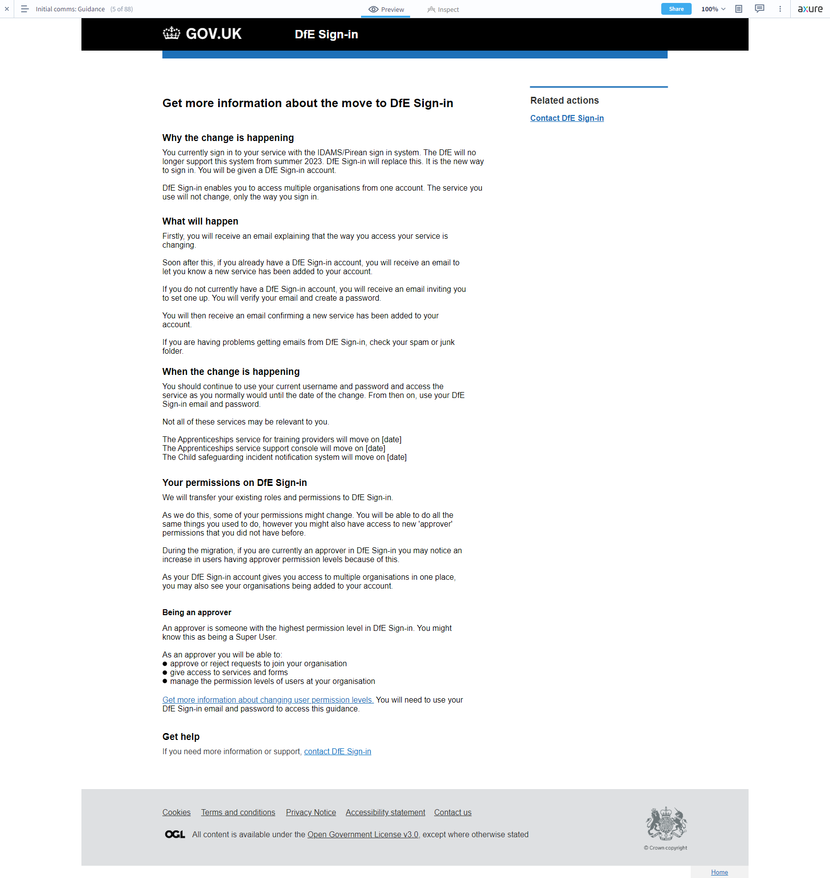

## 

## **Initial comms - landing page content**

#### First draft

**Important**

From [date], you will need to have a DfE Sign-in account to access this service.

[Get more information about moving to DfE Sign-in](https://dfe-secureaccess.atlassian.net/wiki/spaces/NSA/pages/3242590209/Initial+comms+-+guidance+page#%5BhardBreak%5D%5BhardBreak%5DInitial-comms-guidance-page-for-migrating-users-(second-draft))

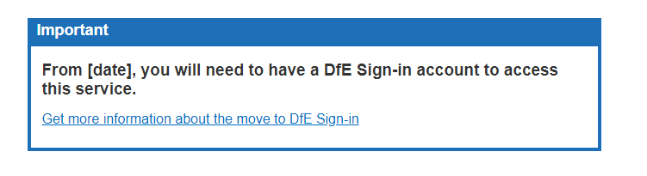

We have never yet iterated this content since the first draft, as there has been not enough feedback and no technical reason to do so

One user did comment, in the first round of user research, “If you hadn't read the email this could be a little confusing”.

We had discussed how detailed or brief to make this banner when originally designed, and chose to make it brief with a link to more detailed guidance. With only one person giving feedback on this, there was not enough evidence to make a change. So we stuck with the original design and recommended further testing.

## 

## **Account set up - email invitation for END USERS**

#### First draft

**Email subject:** You’ve been invited to join DfE Sign-in

**Email body copy:**

Dear [name]

You have been invited to set up a DfE Sign-in account.

To create your account, please verify your email and set your password.

Your verification code

**XXXXXXX**

[BUTTON] Verify email and set password

Kind regards,

The Department for Education Sign-in team

**Need support?**[Contact us for further help](https://help.signin.education.gov.uk/contact-us)

This is an automatically generated email; do not reply.

Received this email in error? No action is necessary.

#### 

#### 

#### Second draft

We added a few words, you have been invited to set up a DfE Sign-in account for [organisation]. We hypothesised that this would help contextualise the email. Further context is provided in the confirmation email that is later received, which lists what service, organisation and permission level has been assigned in DSI.

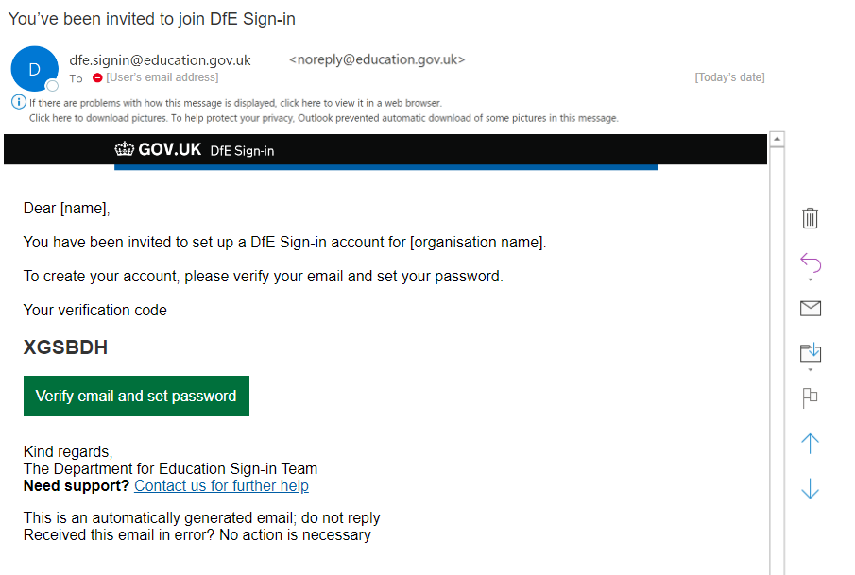

## 

## **Account set up - email invitation for APPROVERS**

#### First draft

**Email subject:** You’ve been invited to join DfE Sign-in

**Email body copy:**

Dear [name]

You have been invited to set up a DfE Sign-in account for [organisation name].

You will have an approver account. Approvers can manage other users at their organisation and add services to their account.

[LINK TO GUIDANCE PAGE] Find out what you can do as an approver

To create your account, please verify your email and set your password.

Your verification code

**XXXXXXX**

[BUTTON] Verify email and set password

Kind regards,

The Department for Education Sign-in team

**Need support?**[Contact us for further help](https://help.signin.education.gov.uk/contact-us)

This is an automatically generated email; do not reply.

Received this email in error? No action is necessary.

#### Second draft

We removed the hyperlink to ‘find out what you can do as an approver’ as it seemed like this was covered by the previous sentence, ‘Approvers can manage other users…’. This made it unnecessary. Plus, this would have taken users to the overall guidance page which holds a lot of information; we were not convinced how quick and effective that help route would be on reflection.

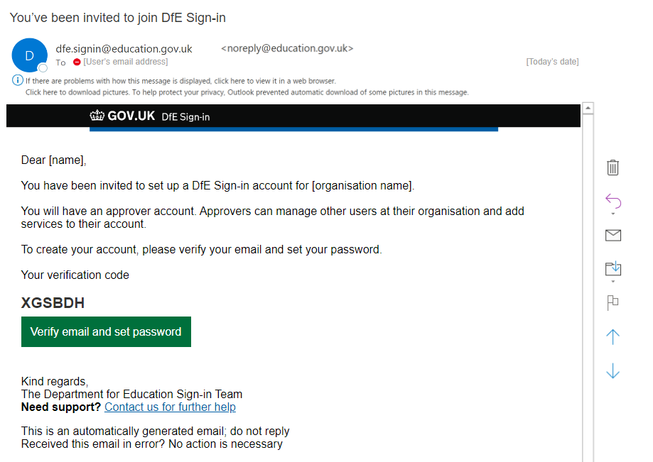

## 

## **Invite journey confirmation page**

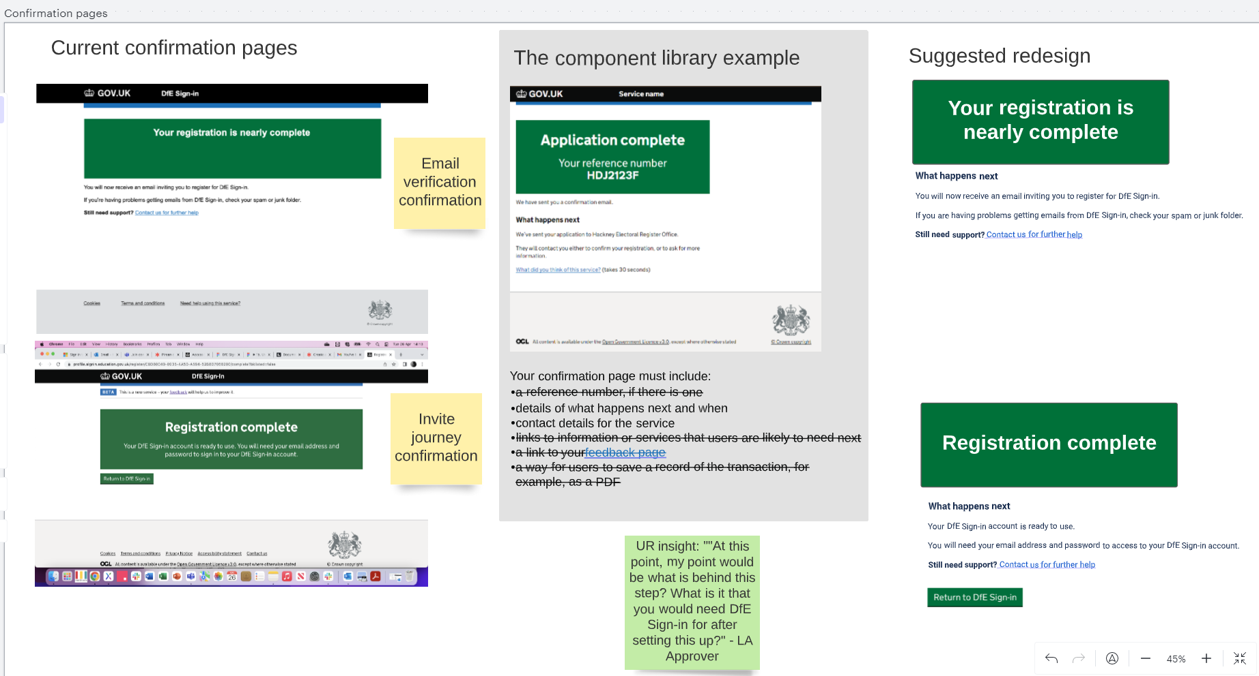

We recommended restyling the confirmation pages across DSI to create consistency between them, and consistency with the GOV.uk component library. Before, they were different from one another and did not follow the component library pattern

**Email verification confirmation before and after (after is not fully styled)**

Note that this journey was later removed. Initially we designed a user journey to chase up users who had not seen the initial email comms before the migration cut off date. It involved a step where they entered their email, and would then be sent an invitation to join DSI. Ultimately we removed this - see cut off warning email for the new design - so didn’t need this confirmation page design

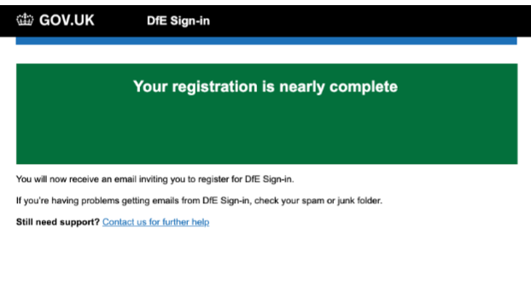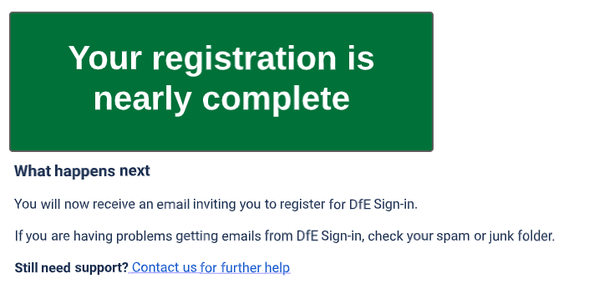

**Invite journey confirmation before and after**

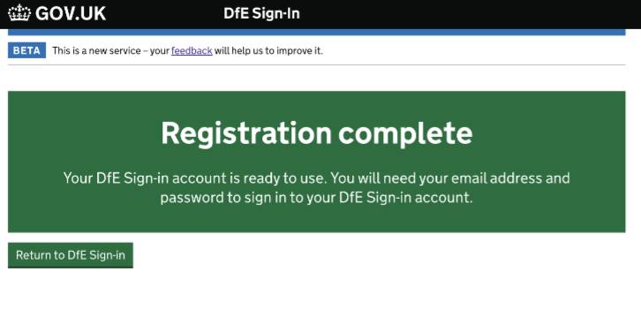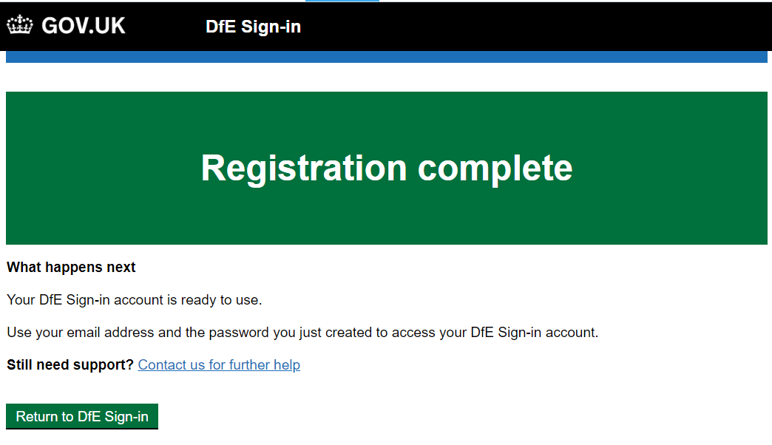

## **Account set up - new service added email FOR END USER**

#### First draft

**Email subject:** New service added to your DfE Sign-in account

**Email body:**

Dear [name]

You can now access [name of service] using your DfE Sign-in username and password.

| **Your account details** |  |
| --- | --- |
| Organisation | [name of organisation] |
| Sub-service [suggest renaming to role] | [type of role] |
| Permission level | [end user/ approver] |

To access this service, sign in to your account and select it from the list on your services page.

[BUTTON] Go to your DfE Sign-in account

Kind regards,

The Department for Education Sign-in Team

**Need support?**[Visit DfE Sign-in Help](https://test-help.signin.education.gov.uk/contact)

This is an automatically generated email; do not reply.

Received this email in error? No action is necessary.

#### Second draft

* A line was added to contextualise that ‘You have recently joined DfE Sign-in’
* You can access this service was pluralised to ‘services from the list below’, as it is possible that a user would be granted access to more than one service at once
* For the same reason, service and sub-services that are now accessible were added to the table, and removed from the opening line ‘You can now access [name of service] using…’
* Status: Approved is a standard field that the existing DSI invite journey shares with users, so this was also included. This design is still being researched - we are unsure if ‘Approved’ could be confused with ‘approver’

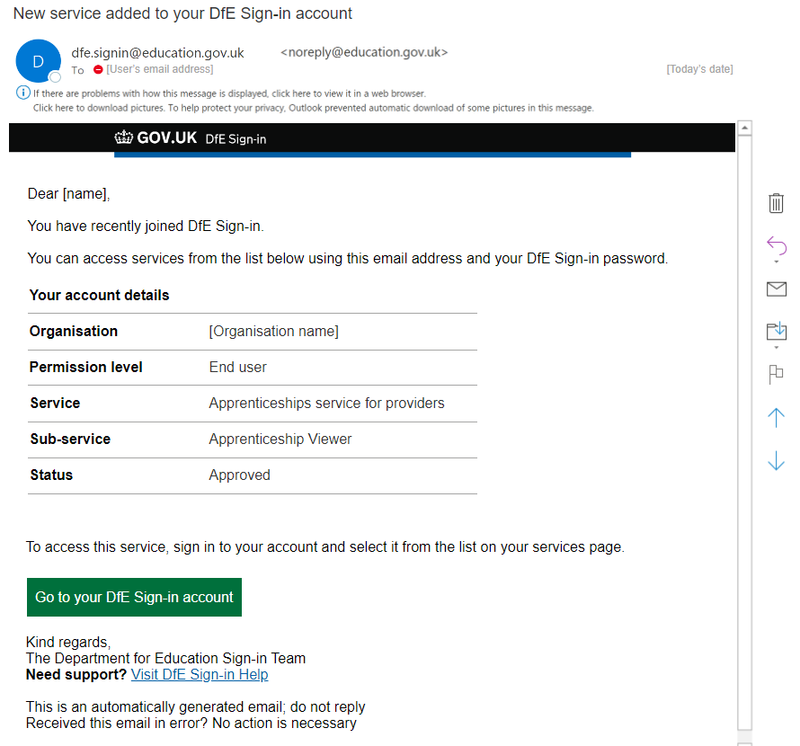

## 

## **Account set up - new service added email FOR APPROVER**

**Email subject:** New service added to your DfE Sign-in account

**Email body:**

Dear [name]

You can now access [name of service] using your DfE Sign-in username and password.

| **Your account details** |  |
| --- | --- |
| Organisation | [name of organisation] |
| Sub-service [suggest renaming to role] | [type of role] |
| Permission level | [end user/ approver] |

You have an approver account. Approvers can manage other users at their organisation and add services to their account.

[LINK TO GUIDANCE PAGE] Find out what you can do as an approver

To access this service, sign in to your account and select it from the list on your services page.

[BUTTON] Go to your DfE Sign-in account

Kind regards,

The Department for Education Sign-in Team

**Need support?**[Visit DfE Sign-in Help](https://test-help.signin.education.gov.uk/contact)

This is an automatically generated email; do not reply.

Received this email in error? No action is necessary.

#### Second draft

All the changes made to the end user email were also applied here. See second draft of the end user email

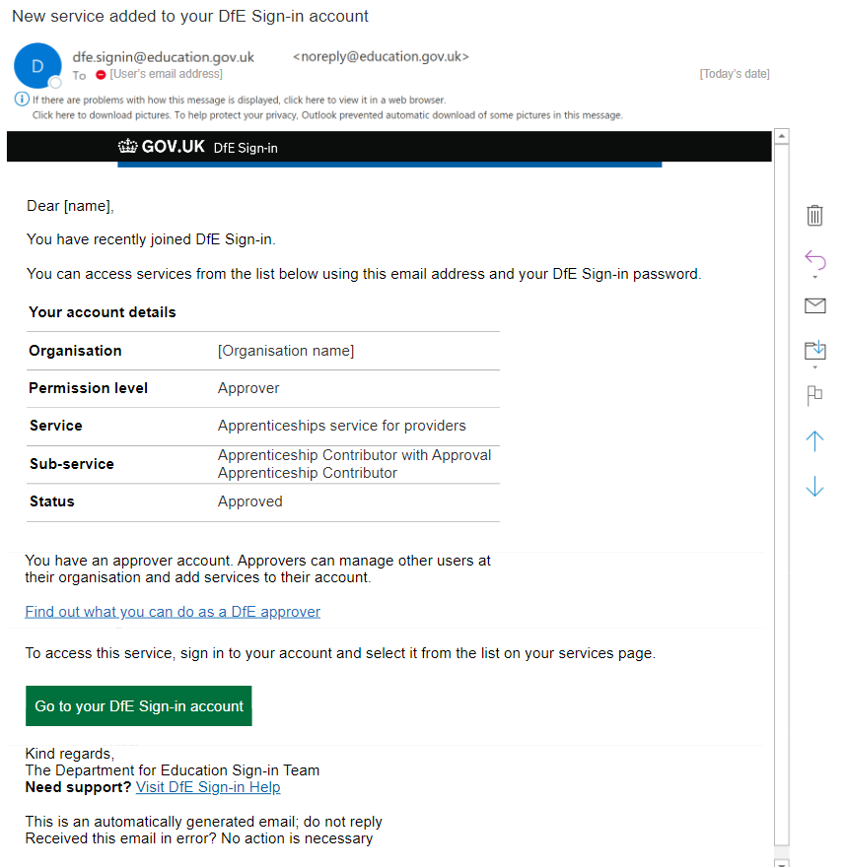

## 

## **Content in DSI - My services page**

We created two potential designs for the my services page, as we were unsure what users would find more logical and understandable.

In one option, the service in the ‘services’ table list is NOT hyperlinked (option A). In the other it is (option B).

#### Option A first draft

**My services**

Here you can access services associated with your account. Need a new service, form, role, or census? Request a service under the related actions menu.

**A :** (!) If you've been told your service is moving to DfE Sign-in, you can only access it from here once it has moved

| **Service** | **Description** |
| --- | --- |
| **A:** NO HYPERLINK Apprenticeship service for training providers | You will be able to access this service from within DfE Sign-in from [date].Until this time, continue to use your current username and password and access the service as you normally would. |

#### Option A second draft

* We redrafted the warning content at the top of the page to specify exactly which service(s) were moving to DfE Sign-in, to remove any chance of misunderstanding
* We changed any mention of the word ‘username’ to email. We did this across the prototype, because DSI uses an email and password sign in approach, whereas Pirean/IDAMS used a username. We wanted to distinguish the two as much as possible to avoid confusion and avoid users trying to use their Pirean/IDAMS username to log in to DSI
* One user in our research noted that saying ‘You will be able to access this service from within DfE Sign-in…’ “Makes it seem like you'll always have to access DfE sign in to access the service, not just that your login details have changed”. This was true. We changed the wording to note that you will be able to access the service from this page, with DfE Sign-in login details.

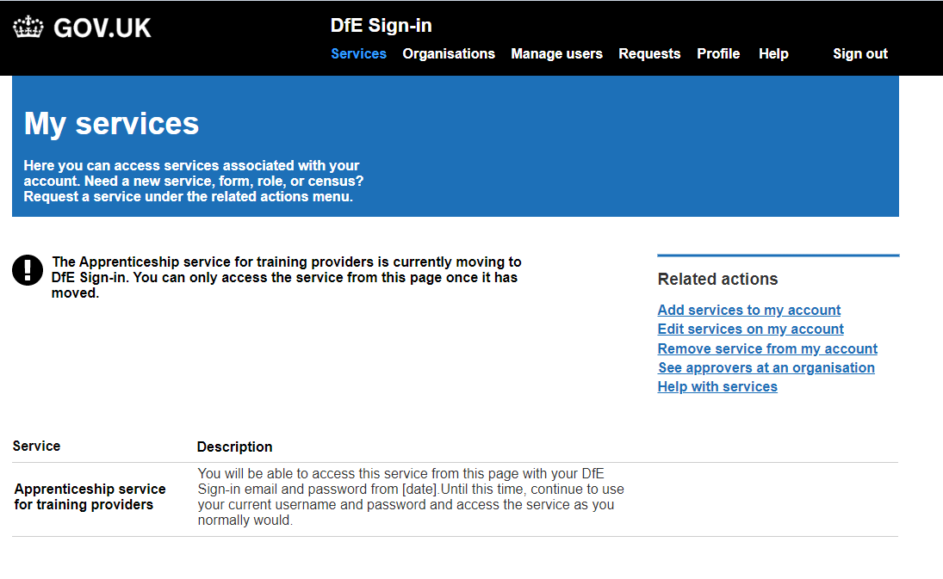

#### Option B first draft

**My services**

Here you can access services associated with your account. Need a new service, form, role, or census? Request a service under the related actions menu.

**B :** (!) If you've been told your service is moving to DfE Sign-in, use your normal username and password until the date of the move. From then on, use your DfE Sign-in username and password.

| **Service** | **Description** |
| --- | --- |
| **B:** WITH HYPERLINK Apprenticeship service for training providers | This service is moving to DfE Sign-in. Use your normal username and password until the date of the move. From then on, use your DfE Sign-in username and password. |

#### Option B second draft

Just like for option A, we redrafted the warning content at the top of the page to specify exactly which service(s) were moving to DfE Sign-in. This aims to remove any vagueness.

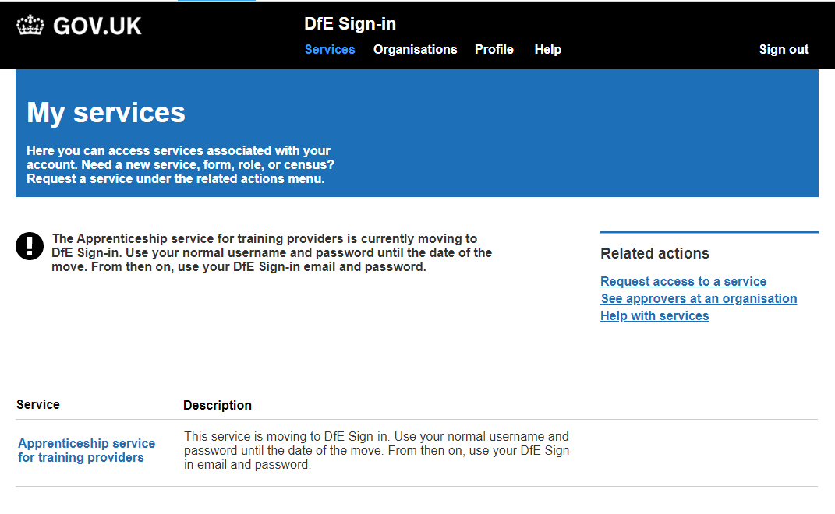

## 

## 

## **Cut off warning email**

#### First draft

**Email subject**: You must take action to keep accessing [name of service]

**Email copy:**

Dear [name]

The way you access [service name] is changing.

From [date], you will need to have a DfE Sign-in account to access this service.

[Get more information about the move to DfE Sign-in](https://dfe-secureaccess.atlassian.net/wiki/spaces/NSA/pages/3241345025/Initial+comms+-+first+email#)

Confirm your email address to set up your account.

[BUTTON] Confirm email

Kind regards,

The Department of Education Sign-in team

This is an automatically generated email; do not reply

Received this email in error? No action is necessary

#### Second draft

The second draft of this email focuses on getting the user to follow the ‘create an account’ journey more than the first draft. This is why the instructions and button to create an account come higher, and the hyperlink to ‘Get more information about the move…’ is moved to the bottom of the email

We also created a version for approvers. It gives high level information about what an approver can do, and identifies that ‘you have been invited to set up an APPROVER account’ but otherwise is the same.

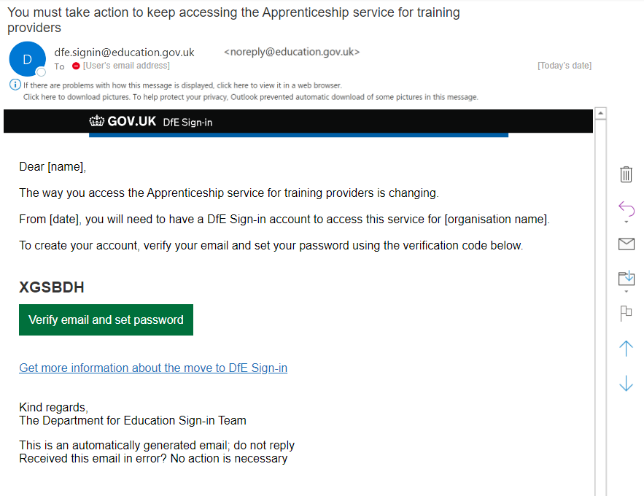

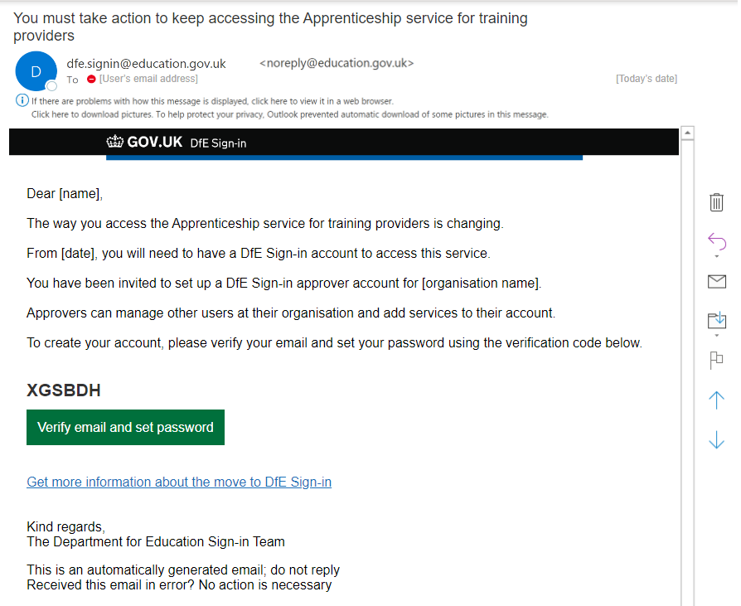

## 

## **Post-migration confirmation email**

#### First draft

**Email subject:**

Your access has changed: [service name]

**Email copy:**

Dear [name]

The way you access [service name] has changed.

You must now use your DfE Sign-in email and password to access this service.

[GREEN BUTTON] Go to the service

[Get more information about the move to DfE Sign-in](https://dfe-secureaccess.atlassian.net/wiki/spaces/NSA/pages/3241345025/Initial+comms+-+first+email#)

Kind regards,

The Department of Education Sign-in team

**Need support?**[Contact us for further help](https://help.signin.education.gov.uk/contact-us)

This is an automatically generated email; do not reply

Received this email in error? No action is necessary

#### Second draft

Only a small change was applied, stating you must now use THIS email address and your DfE Sign-in password. This was based on observations from user research that not all users understood what their ‘username’ would be; one expected it to be sent to them, one wasn’t clear of their login details. This aims to be more specific and instructive.

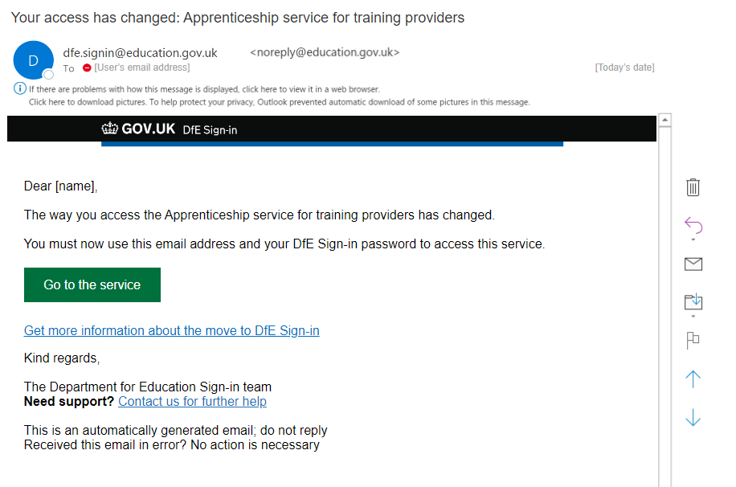

## 

## **Post-migration ‘You still need to set up an account’ email**

#### First draft

**Email subject**: You must take action to keep accessing [name of service]

**Email copy:**

Dear [name]

The way you access [service name] has changed.

You now need to have a DfE Sign-in account to access this service.

We have previously contacted you about setting up an account. You can do this now. Confirm your email address to set up your account.

[BUTTON] Confirm email

Find out more about why this change has happened [LINK TO GUIDANCE PAGE]

[Contact us for further help](https://help.signin.education.gov.uk/contact-us)if you are having difficulty setting up your account.

Kind regards,

The Department of Education Sign-in team

This is an automatically generated email; do not reply.

Received this email in error? No action is necessary.

#### Second draft

* We made edits to the opening sentence to make it clearer that you cannot use your old username and password and need a new access method
* We added information about which organisation the account would be for, for additional context
* We designed an end user and an approver version; the approver version is the same except for high level information about what being an approver entails

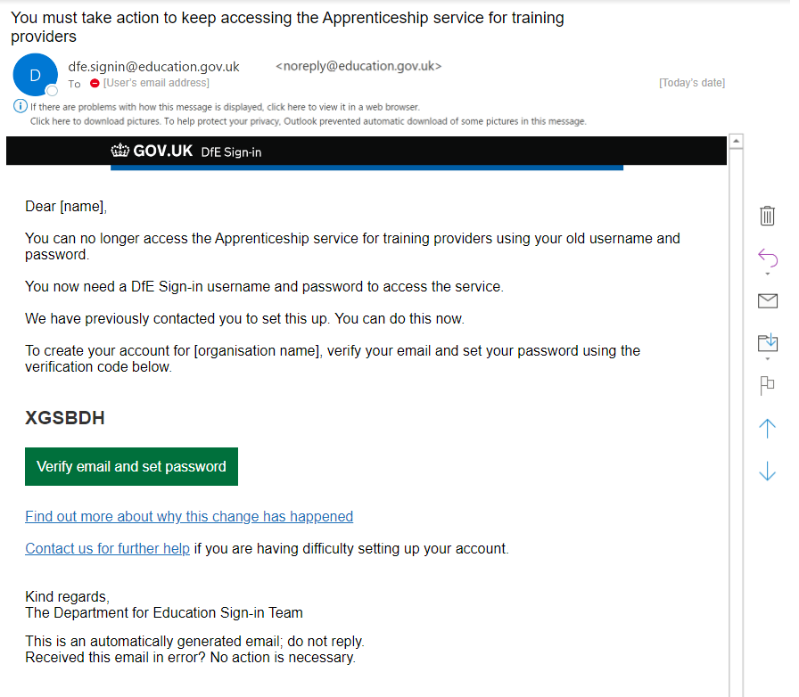

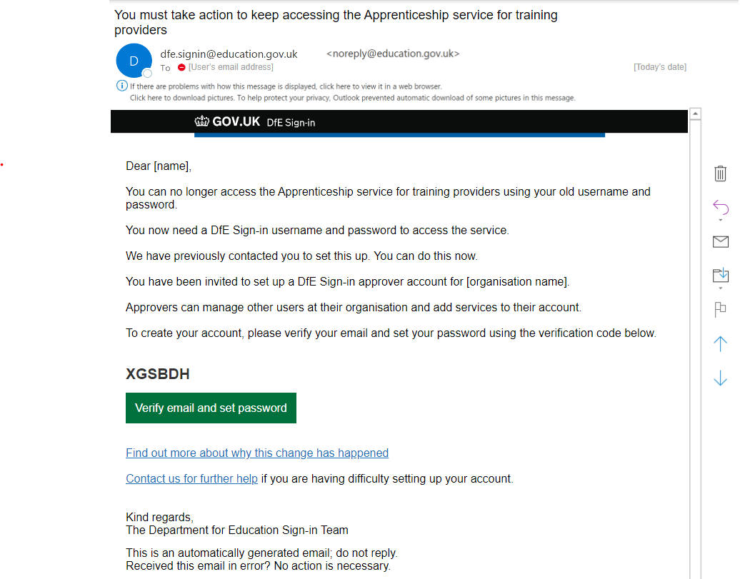

## 

## **Post-migration service landing page and DSI sign in page**

#### First draft

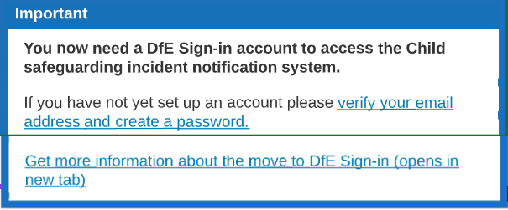

#### Second draft

We discovered through user research that saying ‘now’ and ‘not yet’ made users believe that this journey was personalised and tailored to them specifically. However, it appears for any user on the service landing page. Removing these terms meant removing confusion for those who had already set up their account.

